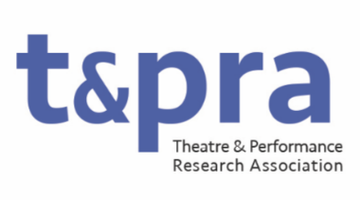

Research Officer: Development and Public Engagement

The Research Officer for Development and Public Engagement will support researchers at all levels and advocate for Theatre and Performance research and researchers with the general public. The officer will oversee the TaPRA Fellowship (for ECRs) and develop other research support and mentorship opportunities, working responsively to the shifting priorities of our fields. They will review and develop TaPRA’s engagement frameworks with a view to enhancing member participation in the organisation and connecting TaPRA’s work and members to the broader, public field of theatre research and practice. They will also organise opportunities to share theatre and performance research outside of the academy, working with external organisations where appropriate (including in the development of TaPRA Fellowship opportunities).
The Research Officer will have a demonstrable commitment to equitable and ethical practices in theatre and performance research and actively develop strategic and practical ways to support research from groups historically underrepresented by the discipline. Working with the wider Executive Committee, they will develop sustainable practices for TaPRA and the fields it represents.
Please note: The post is for three years. The post can be shared between two people or held by one person, but usually TaPRA only has resource to subsidize conference participation for one person for each Executive Committee role.
Duties may include, but not be limited to:
- developing and overseeing the TaPRA Fellowship, in collaboration with ECR Officer/s;
- arranging curated panels, workshops, and other mentorship opportunities at and outside of the annual conference, including one executive-sponsored plenary event at each conference;
- working with the Chair/s to liaise with external partners, including external scholarly bodies and arts organisations;
- developing, reviewing and promoting TaPRA’s public engagement frameworks, such as: the TaPRA manifesto, member-participation processes and field-wide initiatives including TaPRA’s BDS Resolution;
- supporting Awards Officer/s by contributing to review and development of specific awards, and supporting PGR Essay Prize mentorship process;
- attending and contributing to regular online meetings of the Executive Committee.

