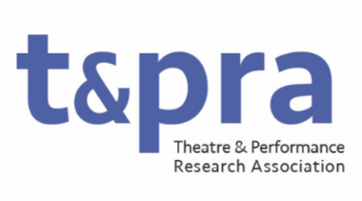

TaPRA Communications Officer

The Communications Officer is responsible for ensuring the welcoming, coherent and professional presentation of TaPRA as an organisation. In this capacity, their role includes the oversight and implementation of all elements of communications about the activities of the organisation and to/with TaPRA current and potential membership. They will lead projects on improving and refining TaPRA’s digital presence, including the website and social media. They are also responsible for the running of election processes as well as the online infrastructure for prizes and awards.
They will have a demonstrable commitment to equitable and inclusive practices in Theatre and Performance research and will bring this commitment to reaching, and to developing new ways of promoting and celebrating research from, individuals and groups historically underrepresented in the discipline of Theatre and Performance Studies.

Duties may include, but not be limited to:
- Managing the process of nominations, shortlisting, and awarding all TaPRA prizes
- Working with the TaPRA administrator, acting as the main point of communication between members and the Exec;
- Curating and sending out the TaPRA newsletter;
- Taking responsibility for social media campaigns and regular social media updates;
- Maintaining and developing the TaPRA website;
- Liaising with conference convenors and to promote the annual conference and enable booking online (if required);
- Managing communications and nomination processes related to online elections and prize/award nominations;
- Writing and editing updates and notices to membership
- Attending and contributing to meetings of the Executive Committee (currently approximately 9 times per year, held primarily online).

