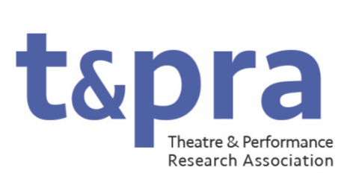
TaPRA Early Career Researcher (ECR) Representative

The ECR Representative fulfils a vital role as a full member of TaPRA’s Executive Committee and the wider organisation, providing support for and insight from the ECR community to the organisation.

For the purposes of this role, an ECR is defined as somebody who is within 3 years of the completion of their doctoral level degree OR ELSE somebody without a PhD who is not registered for a postgraduate degree and who is within the first 3 years of a role (or series of roles) that includes research in theatre and performance disciplines.

This is an exciting and rewarding position open to anyone from the above community. The role holder must meet the definition above at the point they join the TaPRA Executive Committee.

While you do not have to be a current member of TaPRA to be nominated for the role, you do need to become a member (and pay membership fees) in order to take it up. There is no pay or honorarium attached to this role; however, all reasonable costs related to fulfilling it will either be paid in advance or reimbursed.

The main duties include:
- reporting to the Executive Committee about ECR activities and issues and working closely with other TaPRA Executive Officers to promote and support the needs of the ECR community;
- working with the PG Representatives and Research Officer (Development and Public Engagement) on the TaPRA Executive Committee to facilitate the transition from postgraduate to postdoctoral status, and to support those who are new to research roles within the academy and other research organisations;
- representing the TaPRA ECR community in other national and international events and forums;
- liaising between the TaPRA Executive Committee and Annual Conference organisers regarding the needs of ECRs, and organizing/hosting an ECR Welcome event at the conference;
- attending meetings of the Executive Committee (currently approximately 9 times per year, held online);
- soliciting feedback, where appropriate, from the ECR community about the work of TaPRA and the needs of the ECR community;
- actively promoting TaPRA to prospective members.

The ECR Representative is intended as an open and approachable point of contact for all new members of TaPRA but especially for the ECR community. As part of this, the role holder must be fully committed to equality and diversity. The ECR Representative should be confident in their ability to represent the needs of a broad and heterogeneous ECR community, thus helping to ensure the organisation represents and works to support those pursuing theatre and performance research at all levels.

