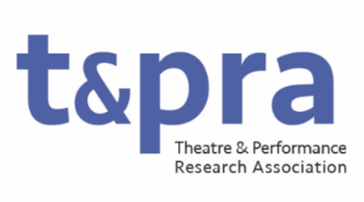

TaPRA Research Officer: Awards

The Research Officer: Awards will showcase and champion excellence in Theatre and Performance Research through the management of the TaPRA Prizes. The elected officer will also work with the Research Officer for Development and Public Engagement, Chair, and the Executive Committee to review TaPRA’s prizes, processes, and criteria, and to actively look for new ways to celebrate research in the field.
They will have a demonstrable commitment to equitable and inclusive practices in Theatre and Performance research and will bring this commitment to TaPRA’s awards, working with the Executive Committee to develop new ways of promoting and supporting research from groups historically underrepresented by the discipline of Theatre and Performance Studies.

Duties may include, but not be limited to:
- Managing the process of nominations, shortlisting, and awarding all TaPRA prizes
- Chairing prize panels
- Periodically reviewing prizes, criteria and opportunities in dialogue with the Research Officer for Development and Public Engagement, the Chair, and the Executive Committee
- Working with the Communications Officer to promote and celebrate TaPRA prizes and awardees
- Attending and contributing to meetings of the Executive Committee (currently approximately 9 times per year, held primarily online).

