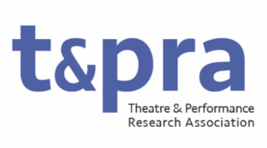

Research Officer: Development and Public Engagement

The Research Officer for Development and Public Engagement will support researchers at all levels and advocate for Theatre and Performance research with the general public. Working with the Postgraduate and Early Career Researcher representatives, the officer will actively develop career development and mentorship opportunities for postgraduate and Early Career Scholars. They will develop workshops, panels, and other research support opportunities for researchers at all levels on topics including publishing, grant capture, Practice Research, research assessment and knowledge exchange. They will also work to develop and organise opportunities to share and produce Theatre and Performance research outside of the academy, working with external organisations where appropriate (including in the development of TaPRA Fellowship opportunities.
The Research Officer will have a demonstrable commitment to equitable and inclusive practices in Theatre and Performance research and actively develop strategic and practical ways to support research from groups historically underrepresented by the discipline. Working with the Research Officer for Awards and the wider TaPRA Executive Committee, they will develop sustainable practices for inclusion and equality within TaPRA and the fields it represents.

Duties may include, but not be limited to:
- Arranging curated panels, workshops, and other mentorship opportunities at and outside of the annual conference
- Developing public engagement and fellowship opportunities for TaPRA researchers
- Chairing TaPRA prize panels
- Working with the Chair to liaise with members of external bodies and organizations
- Attending and contributing to meetings of the Executive Committee (currently approximately 9 times per year, held primarily online).

