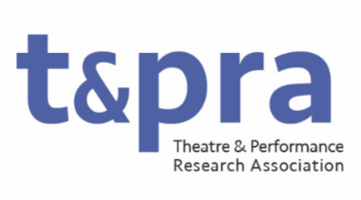

Working Group Coordinators on TaPRA Executive Committee

Working Group Co-ordinators are responsible for supporting and maintaining a vibrant, thriving and welcoming culture within and for TaPRA’s Working Groups, which are the heart of the organisation.
They liaise with Working Groups convenors and represent their needs to the Executive Committee. There are usually 2 or 3 Co-ordinators on the Executive Committee, who work together in recognition of the scale of this role. They are responsible for supporting and maintaining an overview of Working Group activities, and advising the Executive Committee if any groups seem to become inactive or under-subscribed. They advise and represent those members who want to set up new groups to Executive Committee meetings.
They will have a demonstrable commitment to equitable and inclusive practices in Theatre and Performance research and will bring this commitment to enabling individuals and groups who are historically underrepresented in the discipline of Theatre and Performance Studies to become involved in Working Group activity (including as Convenors).

Duties may include, but not be limited to:
- Acting as the main point of contact on the Executive Committee with regards all Working Group activities, and maintaining oversight of the annual calendar of events;
- Advising Working Groups on expectations, and creating and maintaining guidelines for their running and organisation;
- Supporting Working Groupss in planning and disseminating information related to the annual conference;
- Supporting Working Groups convenors to organise TaPRA events outside the annual conference;
- Organising regular meetings of and/or communications with Working Group Convenors;
- Ensuring that all Working Groups have engaged and active Convenors;
- Keeping an accurate record of Working Group Convenors and how they can be contacted;
- Overseeing the length of time that Convenors remain in post and supporting replacement processes every three years;
- Advising members who want to set up new Working Groups based on the TaPRA guidelines for setting up new groups which they maintain and review regularly;
- Attending and contributing to meetings of the Executive Committee (currently approximately 9 times per year, held primarily online).

