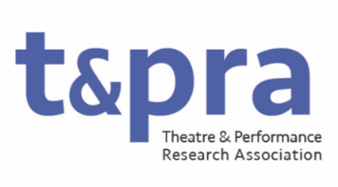

Chair of TaPRA: Role Description

The main responsibility of the Chair is to lead TaPRA, both strategically and as a role model, in ways that support and advance the aims, core values and purposes of the organisation as expressed in the Constitution. They are a Director of TaPRA Ltd. and are subject to all of the responsibilities therein.
The Chair leads TaPRA’s Executive Committee by identifying the key governance decisions to be made; ensuring well founded and transparent decision-making; and managing potential conflicts of interest. They will create productive relationships between members of the Executive Committee and facilitate an environment in which all Executive members are able to fulfil their roles so that the work of TaPRA is delivered in a rewarding way. Working with the Vice-Chair, they ensure the financial health of the organisation.
They will have a demonstrable commitment to anti-racist, equitable and inclusive practices in Theatre and Performance research and will bring this commitment to enabling the scholarship and careers of individuals and groups who are historically underrepresented in these disciplines.
This is a non-salaried voluntary position which requires, on average, 24 days of work each year.

Duties may include, but not be limited to:
- Chairing meetings of the Executive Committee (currently approximately 9 times per year, held primarily online);
- Chairing the Annual General Meeting (AGM);
- Financial approval (e.g. of expenditure and budgets);
- Chairing or judging prize panels;
- Liaising and collaborating regularly with other leaders of higher education and research organisations in the performing arts, nationally and internationally, to shape, steer and support the field and its researchers;
- Responding on behalf of the discipline (often working in partnership with the Standing Conference of University Drama Departments) to consultation requests from governmental and research bodies and organisations, as well as making nominations to the REF sub-panels, etc.;
- Setting the tone and priorities of the organisation, and field more broadly, through a variety of communication platforms, including the design of and opening/closing remarks to annual conferences and events, commentary in membership newsletters, and in media;
- Representing, sharing and celebrating the achievements and concerns of the TaPRA membership.

