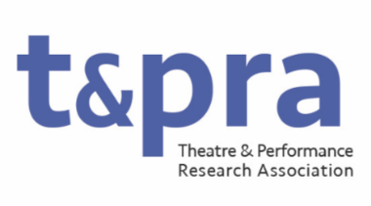
Communications Officer: Membership Secretary
Role Description

The main responsibility of the Communications Officer: Membership Secretary is to monitor, maintain and review the list of TaPRA Members, facilitating membership engagement by working closely with the Communications Officer in drafting and sending key updates, announcements, and newsletters. The secondary responsibility of the Communications Officer: Membership Secretary is to support the internal work of the Executive Committee by facilitating online elections and organising the meetings of that Committee.
The Communications Officer: Membership Secretary sits on TaPRA’s Executive Committee. They will manage TaPRA’s general email account, and respond to queries in a timely fashion. They will ensure that the membership list is up-to-date, and be a key point of liaison between the Executive Committee and TaPRA membership. They will facilitate the scheduling of and document the meetings of the Executive Committee.
They will have a demonstrable commitment to equitable and inclusive practices in Theatre and Performance research and will bring this commitment to the organisation and planning of the annual conference.
This is a non-salaried voluntary position. Duties may include, but are not limited to:
- Acting as the main point of communication between members and the Executive Committee;
- Writing and editing updates and notices to membership;
- Curating and sending out the TaPRA newsletter;
- Managing communications and nomination processes related to online elections, in collaboration with the Communications Officer: Website and digital;
- Managing and monitoring TaPRA’s general email account;
- Managing, updating and reviewing TaPRA’s membership list;
- Scheduling and minuting meetings of TaPRA’s Executive Committee.
- Attending and contributing to meetings of the Executive Committee (currently approximately 9 times per year, held primarily online).

