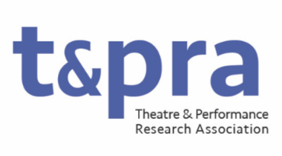

TaPRA Communications Officer: Website and Digital
Role description
The Communications Officer: Website and Digital is responsible for ensuring the welcoming, coherent and professional presentation of TaPRA as an organisation. In this capacity, their role includes the oversight and implementation of all elements of communications about the activities of the organisation and its current and potential membership. They will lead projects on improving and refining TaPRA’s digital presence, including the website, social media, and administering communications and submissions relating to TaPRA’s awards. Some prior knowledge of web maintenance is therefore desirable, although not essential as some training videos have been made and there will be a robust handover with the current postholder, too.
The postholder will have a demonstrable commitment to equitable and inclusive practices in Theatre and Performance research and will bring this commitment to reaching, and to developing new ways of promoting and celebrating research from, individuals and groups historically underrepresented in the discipline of Theatre and Performance Studies.
This is a non-salaried voluntary position. Duties may include, but are not limited to:
- Maintaining and developing the TaPRA website;
- Updating and managing the website as a point of communication and information for members and the general public;
- Taking responsibility for social media campaigns and regular social media updates;
- Liaising with conference convenors to support promotion of the annual conference and to enable booking online (if required);
- Supporting the Research Officer: Awards by administering communications relating to award nominations, shortlisting, and awarding TaPRA prizes, including management of submitted files;
- Attending and contributing to meetings of the Executive Committee (currently approximately 9 times per year, held primarily online).

